# Content Page

## Defining the Architecture

## Developing the Components

### Graphical User Interface

### Logic

### Storage

## Testing the System

# 1. Defining the Architecture



Figure 1 - Architecture

The overall architecture is designed around the MVC (Model-View-Controller) pattern in order to achieve the following objectives:

1. ***DUMB* View** – Minimal data processing in the View.
2. ***THIN* Controller** – Only data redirections in the Controller.
3. ***SMART* Model** – Full data processing in the Model.

The *GUI (Graphical User Interface)* component is the main interface between the user and the system. Its main role is to handle high-level UI interactions, which include displaying tasks, hashtag categories, command hints, status messages, and providing autocomplete functionality. It relies on the Logic component for command execution, low-level decision-making and data processing.

The *Logic* component provides a variety of APIs (Application Programmable Interfaces) for the GUI. It handles parsing and execution of commands, generation of status, hint and autocomplete messages, filtration of task lists, and provision of logical data structures. It depends on the Storage component for physical storage.

The *Storage* component is responsible for persistent physical storage. Its functionality includes JSON (JavaScript Object Notation) encoding and decoding of task lists and settings, as well as read/write operations for physical storage.

# 2. Developing the Components

## 2.1 Graphical User Interface

## 2.2 Logic



Figure 2 – Class Diagram of Logic Component

The *Logic* component is based on the Façade pattern. The *Logic Controller* abstracts the complexities of the *Logic Subsystem* from the GUI by acting as an intermediary.

|  |
| --- |
| Note: Only critical APIs are shown in this class diagram. |

### 2.2.1 Action and Hint System



Figure 3 - Action and Hint System

The Action and Hint System applies the Command pattern. It provides two main API methods to handle execution of commands, and generation of hint and autocomplete messages.

|  |
| --- |
| Note: Only critical APIs are shown in this Class Diagram. Dependencies on static libraries like the TaskCatalystCommons are not shown. |

### 2.2.1.1 Executing Commands

The *ActionHintSystemActual* class parses and creates commands in the form of Action objects. These Action objects, if undoable, are stored in a history stack. These actions can then be undone or redone by calling the undoFromStack() and redoFromStack() methods.

Each subclass of Action encapsulates a complete description of how an operation is performed:

|  |  |
| --- | --- |
| Field / Method | Description |
| DICTIONARY: String[] | All commands associated with this action. |
| isThisAction(String) | Static method for matching dictionary. |
| EXECUTE_ERROR, EXECUTE_SUCCESS | Status messages for execution. |
| UNDO_ERROR, UNDO_SUCCESS | Status messages for undo function, if undoable. |
| execute() | Code for executing the action. |
| undo() | Code for undoing the action. |
| isUndoable() | Instance method for checking if action is undoable. |

Table 1 - Action Class Summary

|  |
| --- |
| Hint: To add functionality to the program, you simply have to create a new a new *Action* subclass, and add it to *ActionHintSystemActual*. For the example below, you can refer to Delete.java to supplement your understanding. |

An abridged example of how the Delete operation is carried out is outlined in the following sequence diagram:



Figure 4 - Sequence Diagram for Delete Action

|  |
| --- |
| Note: Some methods are not shown to improve clarity of the sequence diagram. |

When *LogicControllerActual* requests for a command to be processed, *ActionHintSystemActual* first calls the *isThisAction()* methods of all *Action* subclasses until a match is found.

Since Delete.isThisAction(userInput) is true, a *Delete* object is created and the entire user input is passed to its constructor for further parsing. In this case, the task number is extracted from the user input.

Next, the *execute()* command is called. The *Delete* object gets the instance of the *TaskManager*, and calls the *removeTask(int)* method. The *Task* removed will be returned if it exists. By checking if the *Task* is null or not, the *Delete* object can decide whether it should return an error or success *Message*.

Assuming that *Task* is not null, its reference is stored and a success *Message* is returned to the caller. *ActionHintSystem* then checks if the task is undoable, which is true in this case. The *Delete* object is stored into the undo stack, and the *Message* is returned to *LogicController*.



Figure 5 - Sequence Diagram for Undo Action

When undoing the previous command, an Undo object is created in the same fashion as the Delete object.

When the *execute()* method is called, the *Undo* object gets the instance of the *ActionHintSystem* and calls the *undoFromStack()* method. This causes the *undo()* method of the *Delete* object to be called, which generates a *Message* that is eventually returned to the *LogicController*.

Notice that since the *Undo* action is not undoable, it is not stored in the undo stack of *ActionHintSystem*.

|  |
| --- |
| Note: By convention, when implementing an action that is not undoable, the undo() method should return an error Message object. |

### 2.2.1.2 Generating Hint and Autocomplete Messages

The GUI relies on the Action and Hint System to generate hint messages while the user is typing. This is done by passing the entire command to the getMessageUserTyping() method. The Action and Hint System would then generate the corresponding Message objects to either display a hint or perform an autocomplete operation.

A message object encapsulate the following information:

|  |  |
| --- | --- |
| Field / Method | Description |
| message: String | All commands associated with this action. |
| type: MessageType | Static method for matching dictionary. |
| getType(): MessageType | Returns the message type. |
| getMessage(): String | Returns String stored in the message. |

Figure 6 – Message Class Summary

The execute() and undo() methods of Action objects generate status Message objects with the SUCCESS and ERROR types, which are meant to be displayed in the GUI’s status bar after commands.

On the other hand, the getHint() method of Action objects generate Messages of HINT and AUTOCOMPLETE types. Hints are displayed on the status bar like success and error messages, while autocomplete prompts the GUI to replace the user’s input bar with the encapsulated message.

The Action and Hints System generates hints for partial command matches, as well as hints specific to a command if there is a match. The following flow chart illustrates the hint generation process:



Figure 7 - Hint Generation Flow Chart

As of writing, with the exception of Edit and Add, the getHint() methods of most commands generate static hints. Edit can return Autocomplete messages, while Add implements the Live Task Preview system.

### Autocomplete and Live Task Preview



Figure 8 - Edit Autocomplete Flow Chart

|  |
| --- |
| Hint: Look in Edit.java to see the exact implementation of each conditional in the decision tree. |

The above diagram shows the decision tree used by the getHint() method of the Edit Action. If the specified task exists, an AUTOCOMPLETE message is generated by pulling the Task from the Task Manager and appending its full description behind the command.

|  |
| --- |
| Note: When generating AUTOCOMPLETE messages, make sure it contains the exact command the user should type. For example, the parameter “edit 2 “ should generate an AUTOCOMPLETE message containing “edit 2 Meet boss at 5PM”, and not simply “Meet boss at 5PM”. Also, make sure to use getTaskDescriptionEdit() from the Task object to preserve ignore tags (explained in the parsing section below). |

If the specified task exists, and the command is already filled in, then Live Task Preview messages will be generated. These are messages of type HINT, which makes use of parsing libraries contained in TaskCatalystCommons to generate a preview of the system’s NLP (Natural Language Processing) interpretation of the command.

Live Task Preview messages are also the main type of Messages generated by the Add Action. Task parsing and building will be discussed in the next section.

### 2.2.1.3 Adding Tasks



Figure 9 - Class Diagram for Add Action

The Task Builder is used by the Add action to parse and create Task objects. As the project implements the “Natural Bucket”, there is a requirement for flexibility in command. The system makes use of the PrettyTime NLP library to recognize date and time formats. However, its behavior is inconsistent across various scenarios. There is also a need to have Relative Date Display. Therefore, the solution is to convert a Task description to something that is more easily understood, parsed and displayed later on.

An Add object passes the user input to Task Builder, which in turn sends it to TaskCatalystCommons for parsing. The following table shows an example of converting a Task description into a format that is more easily handled by the displaying function later on:

|  |  |  |
| --- | --- | --- |
| Process | Interpreted Input | Parsing Input |
| Original User Input | Meet client in MR5 at 5pm to 6pm. Phone number 91234567. |  |
| Ignore all number strings longer than 4 digits. | Meet client in MR5 at 5pm to 6pm. Phone number [91234567]. |  |
| Ignore all words ending with a number. | Meet client in [MR5] at 5pm to 6pm. Phone number [91234567]. |  |
| Remove all ignored words for the Parsing Input. |  | Meet client in at 5pm to 6pm. Phone number. |
| Remove all PrettyTime buggy words for the Parsing Input. |  | Meet client 5pm to 6pm. Phone number. |
| Remove consecutive “and”, “on” and whitespaces. |  | Meet client 5pm to 6pm. Phone number. |
| Send Parsing Input to PrettyTime, and replace each match that has absolute word boundaries and are outside of square brackets in Interpreted Input. | Meet client in [MR5] {12 Oct 2014 05:00 PM} to {12 Oct 2014 06:00 PM}. Phone number [91234567]. |  |
| Remove all prepositions before each date. | Meet client in [MR5] {12 Oct 2014 5PM} to {12 Oct 2014 6PM}. Phone number [91234567]. |  |

The Interpreted Input is returned to TaskBuilder and stored as the Task’s Description. Whenever the getDescription() method of the Task is called, it uses the TaskCatalystCommons library to convert it into a friendlier format for displaying.

|  |
| --- |
| Note: Square brackets are used to ignore parts, while curly braces are used to denote date and time information. |

The process of converting from an Interpreted Input to a Friendly String for displaying is shown below:

|  |  |
| --- | --- |
| Process | Friendly String |
| Original Interpreted Input | Meet client in [MR5] {12 Oct 2014 05:00 PM} to {12 Oct 2014 06:00 PM}. Phone number [91234567]. |
| Parse items in brackets and replace them with relative dates. | Meet client in [MR5] {today 5PM} to {6PM}. Phone number [91234567]. |
| Remove all square brackets and curly braces. | Meet client in MR5 today 5PM to 6PM. Phone number 91234567. |

When there are more than one date in a sentence, the following code snippet is used by the conversion process to determine relative dates and ensure that there is no repeated information (i.e. “Saturday 5PM to Saturday 6PM” instead of “Saturday 5PM to 6PM”).

|  |
| --- |
| **if** (!*TaskCatalystCommons.isSameDate*(previousDate, currentDate)) {  // Can add some more, like yesterday, last Tuesday, etc.  **if** (*TaskCatalystCommons.isToday*(currentDate)) {  formatString = "'today'";  } **else** **if** (*TaskCatalystCommons.isTomorrow*(currentDate)) {  formatString = "'tomorrow'";  } **else** **if** (*TaskCatalystCommons.isThisWeek*(currentDate)) {  formatString = "'on' E";  } **else** {  formatString = "'on' d MMM";  }  **if** (!*TaskCatalystCommons.isThisYear*(currentDate)) {  formatString = formatString + " yyyy";  }  }  **if** (!*TaskCatalystCommons.isSameTime*(currentDate, nextDate)) {  **if** (!formatString.isEmpty()) {  formatString = formatString + " ";  }  formatString = formatString + "h";  **if** (*TaskCatalystCommons.hasMinutes*(currentDate)) {  formatString = formatString + ":mm";  }  formatString = formatString + "a";  }  SimpleDateFormat formatter = **new** SimpleDateFormat(formatString);  friendlyUserInput = friendlyUserInput.replace(dateGroups.get(i).getText(), formatter.format(currentDate)); |

Figure 10 - Friendly Date Conversion Process

## 2.2.2 Task Manager

Figure 11 - Task Manager Class Diagram

The Task Manager Interface follows the Demeter’s Principle closely by ensuring that most common operations can be done using APIs without low-level manipulation of Tasks. The Task Manager generates the actual Task list displayed to the user by keeping track of the last display mode and keyword used by the user. The keyword can be a hashtag or search key depending on the display mode.

TaskManagerActual is responsible for maintaining the full list of tasks, and depends on a ListProcessor to generate the display list whenever the getList() method is called.

Whenever tasks are added or removed, TaskManagerActual automatically sends the whole list of tasks using the Storage interface of the Storage component.

## 2.3 Storage

The Storage Component does the functions of storing task data in the file and loading the data to perform displaying tasks or editing the contents of the tasks. When the data is stored, you need to convert the list of tasks into JSON objects to save in the file. Similarly, you have to converts JSON data of the file to tasks while loading the list of tasks.

The below class diagram demonstrates the structure of the Storage component.

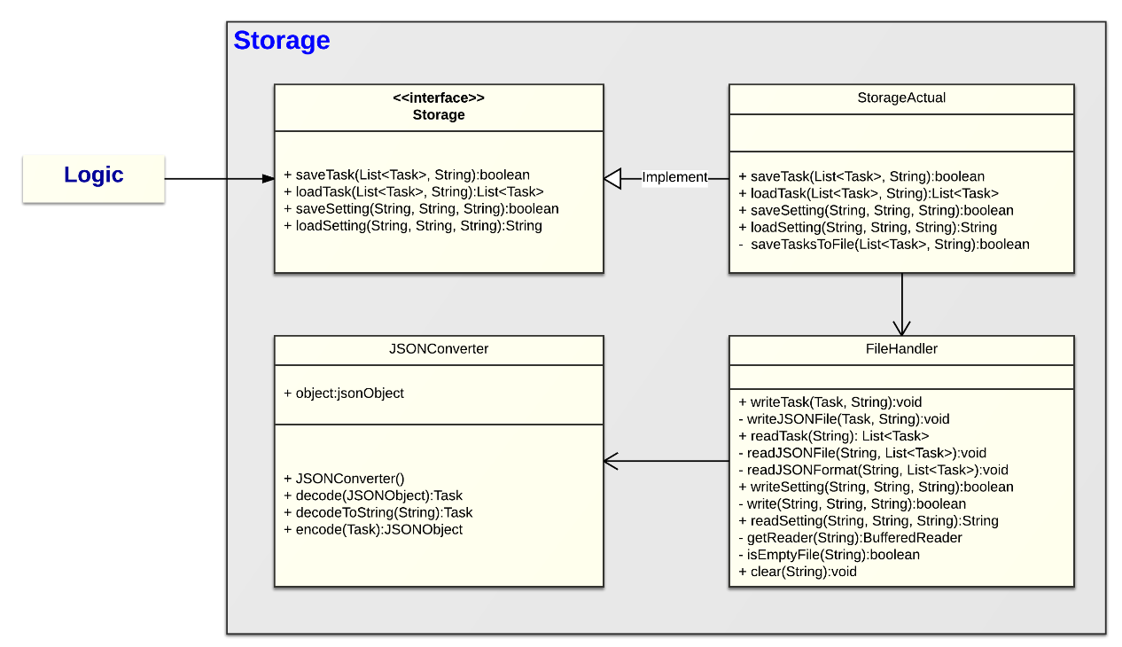

Figure 12 - Class Diagram of Storage Component

The following sequence diagram shows the main functions of saving and loading tasks.

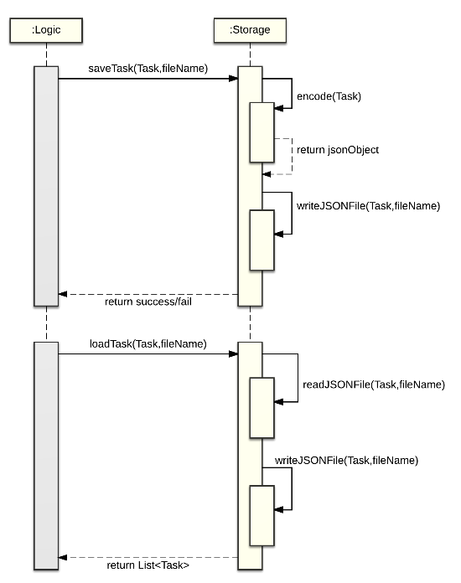

Figure 13 - Sequence Diagram of Saving and Loading Task

# 3. Testing the System

When developing new functionality, the TDD (Test-Driven Development) approach should be applied. More information on how to use the TDD approach can be found in the following URL:

<http://agiledata.org/essays/tdd.html>

JUnit is the main unit testing system used in the project. As the project structure follows the specifications of the Maven dependency management system, JUnit test cases are stored under the /src/test/java directory.



Figure 14 - /src/test/java Directory

To create a new JUnit test case, right click on the project package, and select **New > JUnit Test Case**.

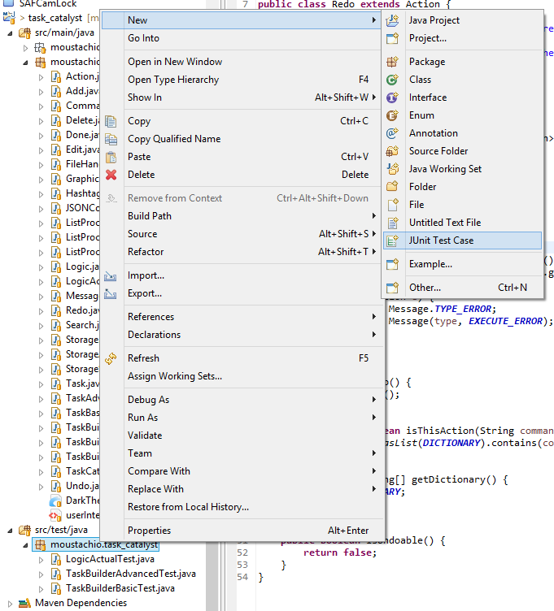

Figure 15 - Creating a new JUnit Test Case

Ensure that your test case follows the naming convention of *ClassName*Test where *ClassName* is the name of the Class Under Test. Also, ensure that JUnit 4 is in use, and the correct class is selected for the “Class under test” field.

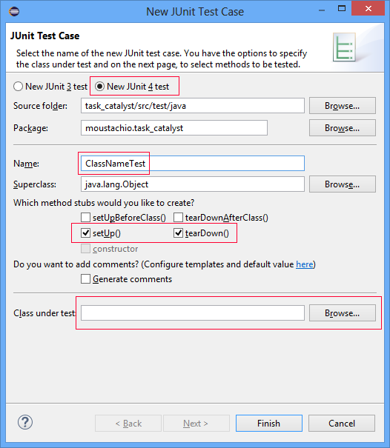

Figure 16 - Creating a new JUnit Test Case

The setUp() and tearDown() methods are called before and after respectively after each test case. Use setUp() to instantiate an instance of the Class Under Test, and tearDown() to perform any cleaning up operations. An example is shown below:

|  |
| --- |
| TaskBuilder taskBuilder;  @Before  **public** **void** setUp() **throws** Exception {  taskBuilder = **new** TaskBuilderAdvanced();  }  @After  **public** **void** tearDown() **throws** Exception {  }  // Test for basic date recognition.  @Test  **public** **void** tc1() {  Task task = taskBuilder.createTask("Meet boss 21 Jun 10:05am");  *assertEquals*("Meet boss on 21 Jun 10:05AM", task.getDescriptionEdit());  }  … |

You can write test cases as shown in the above code. When using TDD, remember to create the smallest test case possible, and pass each test case using the simplest code. You can create additional test cases simply by prefixing them with the @Test directive.

Simply right click the test case and select **Run as > JUnit Test** to run the test.

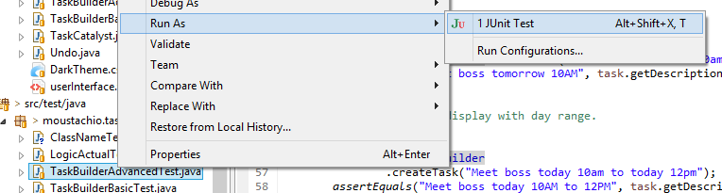

Figure 17 – Running the JUnit Test